Saint Rose Philippine Duchesne: A Heart on Fire across Frontiers

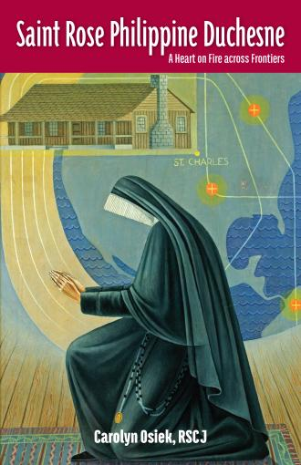

In time for its bicentennial celebration, the Society of the Sacred Heart has published “Saint Rose Philippine Duchesne: A Heart on Fire across Frontiers,” written by Carolyn Osiek, RSCJ.

Two hundred years ago, Rose Philippine Duchesne set out across the Atlantic to establish the Society of the Sacred Heart and educate the children of the new world. Opening the first Catholic school west of the Mississippi, Mother Duchesne, known as “the woman who prays always,” crossed frontiers to bring faith, love and education to the new world.

Carolyn Osiek, RSCJ, is Charles Fischer Catholic Professor of New Testament emerita at Brite Divinity School at Texas Christian University and now provincial archivist for the Society of the Sacred Heart, United States–Canada Province. In this short book on the life of Saint Rose Philippine Duchesne, she brings to life the compelling story of the saint who paved the way for Catholic education west of the Mississippi.

The book is available for order through your local book store or [Amazon.com](https://www.amazon.com/Saint-Rose-Philippine-Duchesne-Frontiers/dp/0997132914/ref=sr_1_1?ie=UTF8&qid=1503939411&sr=8-1&keywords=saint+rose+philippine+duchesne).