Sister Margie Conroy, rscj

*(April 2008)*

Who is she? Where is she? Why are we talking about her?

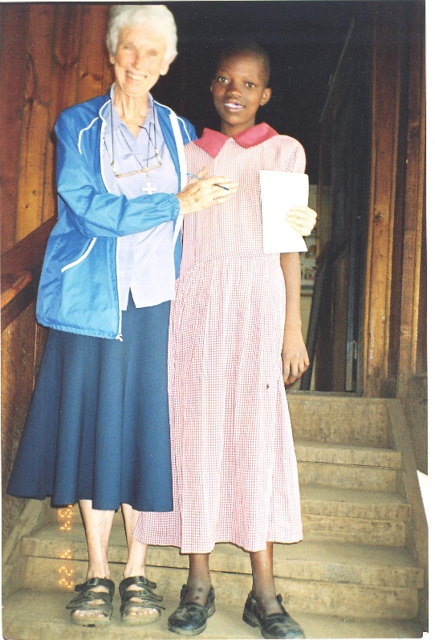

Sister Margie Conroy is a Canadian religious of the Sacred Heart from Newfoundland. She has been working in Africa for more than 35 years. She has lived in Uganda, Chad, and Kenya, especially in the northern part of Uganda where the tribal people live. One of the many things she is doing these days is to talk to prisoners in Africa about God. Since she doesn’t speak the African languages, she needs an interpreter for that. So she thought of a way to talk about God without using too many words, and that is, by putting on plays. This project has been very successful. Prisoners become like little children. They all want to act a part in the play and like that, they learn about how God loves them.

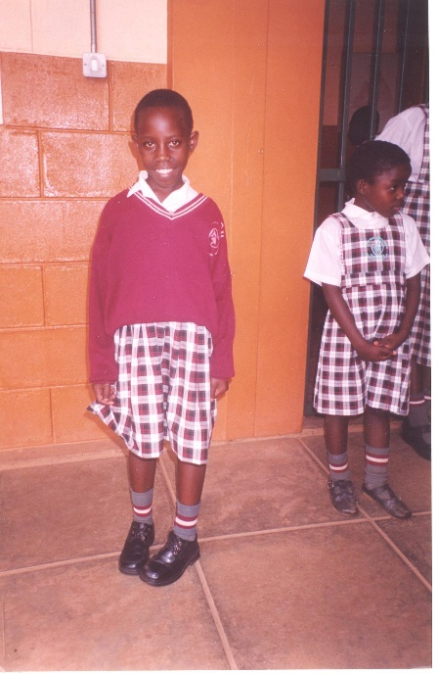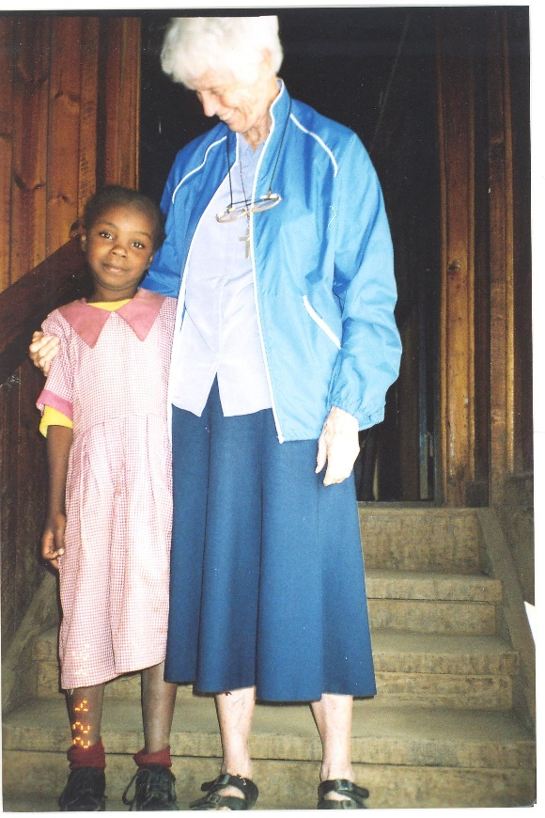About ten years ago, Sister Margie was the provincial in Africa. She went to Nairobi to find a piece of land and to start a school of the Sacred Heart. She passed by a slum and heard a little voice in her heart telling her it’s there the school should be, so that the poorest among the poor children could also have a chance to learn. So the school came to be. If you wish to help her, you can send her money and she will use it to help more children to go to the School of the Sacred Heart in Nairobi.