Flavia Augustine

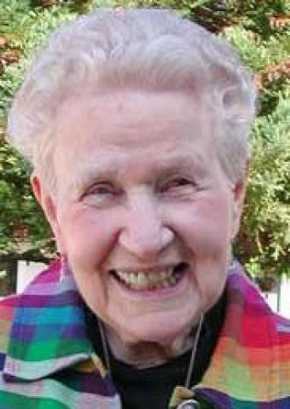

***Birth: Jul. 28, 1914  
Profession: Aug. 2, 1943  
Death: Nov. 18, 2010***

Flavia M. Augustine, RSCJ, beloved educator and mentor, died November 18, 2010, at Oakwood, the Society of the Sacred Heart retirement center, in Atherton, California.

Born in Chicago, Illinois, on July 28, 1914, she was the daughter of Marie Wisnom and Martin G. Augustine, and the eldest of four children. When Mr. Augustine died, Flavia’s mother moved her family to the home of her mother in Minneapolis, Minnesota. After twelve years of public education there, Flavia moved to Omaha, Nebraska, to live with an aunt and uncle. Following a year of travel, she was enrolled in Duchesne College of the Sacred Heart - and her life was changed. On June 27, 1935, after her sophomore year, she entered the Society of the Sacred Heart at Kenwood, in Albany, New York.

Following her first vows at Kenwood on February 11, 1938, Sister Augustine was assigned to the Hardey Prep Sacred Heart School for Boys on Sheridan Road in Chicago, where she soon was put in charge. On August 2, 1943, she made her profession of final vows at Kenwood, and then moved to middle school teaching, first at Duchesne Academy, Omaha, then at the Convent of the Sacred Heart in St. Joseph, Missouri. During that time, she completed her B.A. in history at Duchesne College and her M.A. in history at Creighton University, in Omaha.

While working on her Ph.D. in European history and political science at Catholic University in Washington, D.C., Sister Augustine was sent to Duchesne College as dean of students and history professor. In 1957, sudden illness required that she be sent to Chicago for two surgeries; after recuperation, she became college coordinator and taught history at Barat College, Lake Forest, Illinois. She moved back and forth between Barat and Duchesne until the latter closed in 1968 and she began serving as director of admissions at Barat College.

From 1978 to 1983, Sister Augustine served as college admissions director at the Convent of the Sacred Heart Sheridan Road, providing guidance for college-bound juniors and seniors. Her third career began in 1983 at the Howard Area Community Center, a social service agency in Chicago, where, for ten years, she taught in the G.E.D. program, helping women finish their education and acquire good jobs.

In 2000, at age 86, Sister Augustine moved to Oakwood, where she remained active and participated in a ministry of prayer for almost ten years. She died peacefully surrounded by her sisters.

The funeral Mass for Sister Augustine will take place at Oakwood, on December 11, 2010, at 10:00 o’clock. Mass will be followed by burial in the Oakwood cemetery and sharing of memories in the Oakwood community, 140 Valparaiso Ave., Atherton, CA 94027. Memorial contributions may be made to the Society of the Sacred Heart, 4120 Forest Park Avenue, St. Louis, MO 63108.

Comments

[**Flavia Augustine, rscj**](https://rscj.org/comment/1636#comment-1636)

Submitted by Virginia Fitzgerald on Tue, 2010-12-07 10:21

I remember Sr. Augustine greeting me and my mother in the entry of the Old Main building of Barat College in November of 1975.  We were there for a campus visit.  She was fashionably dressed, warm and gracious.  Exactly what my mother had in mind.  She interviewed me, asking about my studies and interests, and I knew that this was a serious discussion, despite her charm.  
Flav was a character.  She and I enjoyed each other immensely over many years.  Her beloved Marg Green was my teacher and mentor.  My parents never doubted the mutual decision that I attend Barat and be educated in the Sacred Heart tradition.  
I would love to read a full obituary about Flav; her life and accomplishments.

[**Sr. Flavia's full obituary is now posted**](https://rscj.org/comment/1637#comment-1637)

Submitted by help on Tue, 2010-12-07 11:30

Dear Ms. Fitzgerald, you were an hour early. We just posted the full obituary for Sr. Flavia.

[**Flavia Augustine, rscj**](https://rscj.org/comment/1689#comment-1689)

Submitted by Pat Turner on Mon, 2011-05-09 20:19

Flav was my first "boss" in College Admissions at Barat after I graduated in 1971. How I loved working with her, although she could be firm...and I learned so much from her! She was so much fun to travel and shop with, always with a twinkle in her eye. She had lived an interesting life before joining the Sacred Heart order and was passionate about her life as a rscj. It's funny, I alwas think of her related to her birthday as a "Leo" in astrological terms; she was always perfectly polished, outgoing and strong.  I saw her at a reunion many years ago in Chicago, but now I'm sad that I never visited her at Oakwood (since I was in California) to say thank you and tell her what an influence she had on my life.