Kathleen Hughes, RSCJ, Theologian and Author

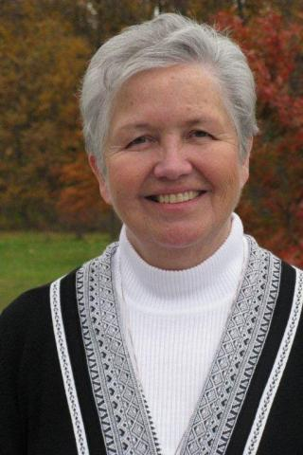

*Sister Kathleen Hughes*

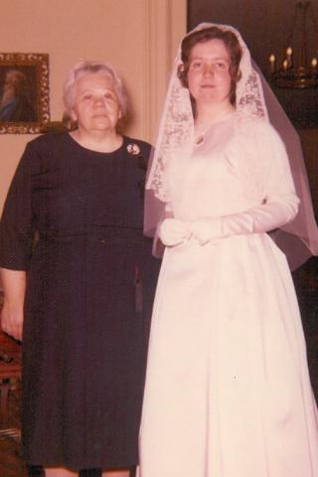

*Preparing for first vows*

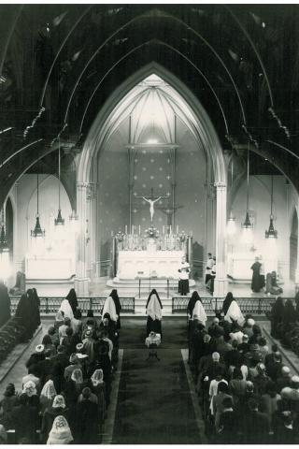

*Profession of First Vows at Kenwood*

**2015 Jubilarian, Celebrating 50 Years as a Religious of the Sacred Heart**

Kathleen Hughes, RSCJ, is a sacramental theologian, teacher, speaker and writer who previously served as provincial for the United States Province (1999-2005). She is now engrossed with issues of spirituality and prayer and the retrieval and reinterpretation of traditional wisdom and practice for contemporary life.

Interestingly, her decision to become an RSCJ was prompted by a joke. One evening at dinner, during her sophomore year at Newton College of the Sacred Heart, her friends were discussing religious life. In the middle of the conversation someone sarcastically said, “of course we all know that Kathy is going to enter the convent.” Everyone roared in laughter in response to the comment, because it seemed so obviously preposterous at the time. However, after a long sleepless night, she knew there was truth to the idea. She felt called towards religious life.

Prior to experiencing this call, she had been introduced to two other religious orders, first in grade school and then later in high school. She joined the Society, though, because she detected something special and unique about each member. She found their life of prayer and contemplative spirits compelling. Sister Hughes loved that each RSCJ was decidedly her own person and not formed from the same mold. As she continued to get to know the order, she was impressed at the RSCJ’s excellent teaching skills and how well-educated, articulate, and passionate they were about their subjects. The RSCJ she met at Newton seemed to love each other and each one of their students. Later, she would realize that was their way of making known God’s love. Ultimately, what drew her to the Society of the Sacred Heart was a conviction that these women supported and sustained each other on their journey into God.

In response to her overwhelming call, she accelerated her studies, and finished at Newton in three years. Sister Hughes made her first vows in 1965 and her final profession in 1970.

Since joining the Society, Sister Hughes has served in various teaching and administrative positions at Stone Ridge School of the Sacred Heart, Washington D.C. and Newton Country Day School of the Sacred Heart, Newton, MA. In 1981, she was the first woman to receive a doctorate in Liturgical Studies from the University of Notre Dame. From 1980 to 1999, she served as a Professor of Word and Worship at the Catholic Theological Union at Chicago and also served a term as Academic Dean.

She was a member of the Advisory Board of the International Commission on English in the Liturgy (ICEL) for nineteen years and chaired the subcommittee that prepared original texts for worship among English speakers across the world. She has written nine books, served on ten editorial boards and published several hundred articles and reviews demonstrating a broad range of interest in worship, sacraments, preaching, language, feminism, and spirituality.

Currently, she serves as a consultant on the formation to mission for the Society of the Sacred heart and the Network of Sacred Heart School across the country. Happily, much of her work over the course of her 50 years since joining the society has been concerned with spirituality in one guise or another so her ministerial life has continually nourished her life with God. She believes that, for an RSCJ, it doesn’t really matter what they do; it matters who they are. It matters that they are faithful to a life of prayer and that they reveal, in all their relationships, the Heart of God the have come to treasure.

[St. Louis/St. Charles](https://rscj.org/rscj-area/st-louisst-charles)

[Jubilarians](https://rscj.org/category/jubilarians)