Peggy McDonnell, RSCJ: Ends of the Earth

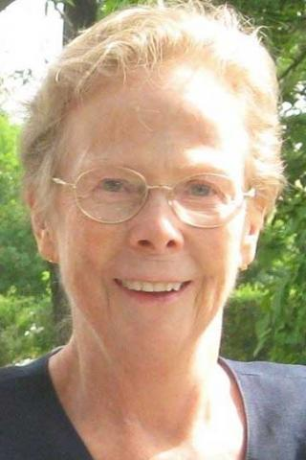

*Sister Peggy McDonnell*

By Holly Marihugh

Sister Peggy McDonnell would go to the ends of the earth for a sick person. And she’s spent decades at the bedside, patiently waiting for a person’s life to unfold. “I have a deep respect for sick people,” the Catholic nun says. “I’m almost in awe of the beauty of the human person. I’ve gotten up at night and during the weekend to be with someone who is dying.”

M. Margaret McDonnell, or Sister Peggy as she’s known, has held the hands of the sick and bereaved and helped families make critical end-of-life decisions about their loved one in Winnetka since 1989. The 77-year-old also is a Registered Nurse and a Medical Ethicist trained at Harvard Divinity School.

When she first put down roots in her neighborhood on Cherry Street, word spread about her, the nun from New Jersey who helps navigate the high waves of illness and passing.

“Neighbors on my block shoveled their own walks and mowed their own lawns,” Sister Peggy remembers. “When you’re outside that way, people get to know each other. That’s how you build community.”

In 1995, Sister Peggy and her Order (Society of the Sacred Heart) established the not-for-profit “Choices,” The Center for Ethics and Advocacy in Healthcare. After seeing patients for years in hospitals and nursing homes, Sister Peggy did an about-face on the location for supporting sick people based on what she saw happening in the houses on her own block. She felt that many in the community needed at-home guidance and advice due to changing health care. For almost two decades now, Sister Peggy has been available to offer direction at a critical life juncture.

“I have great respect for the process that human beings go through when they are approaching death,” Sister Peggy says. “I have never seen anyone not die in peace. I believe there’s a higher power, and therefore, there’s no reason to be afraid of death.”

The choices that a person and family must make approaching death can be like pouring over a thick menu at a restaurant. When patients have compromising, serious health conditions, they need to find the most palatable, fulfilling, and healthy options for everyone in their circle. To put a finger on what’s really important, Sister Peggy has developed a tried-and-true decision-making model. And, she uses moral principles along with the decision process.

“I’m comfortable with tough life stories,” she says. “And I’m totally at ease with a family. We can sit around the dining room table because my approach is very much human. In the end, though, the decisions have to be made by the family.”

After decades of watching faces in pain finally come to peace, the Irish-American nun now finds clarity in an epiphany she had: “I think that death is the final healing from the wounds that we suffer in life.”

— This story was originally published in Holly Marihugh’s blog on Facebook, [Winnetka60093](https://www.facebook.com/winnetka60093/photos/a.1523429007881512.1073741828.1492648814292865/1742008699356874/?type=1)

[Chicago](https://rscj.org/rscj-area/chicago)

[*Bicentennial*](https://rscj.org/bicentennial2018)[*Vocations*](https://rscj.org/vocations)[*Connect*](https://rscj.org/connect)