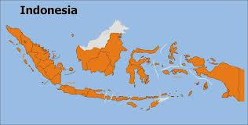CELEBRATE 25 YEARS OF RSCJ IN INDONESIA!

Warm wishes for Christmas and the New Year from all the RSCJ, NSCJ and PSCJ in Indonesia.

A Quarter of a century. We celebrated how long we RSCJ have been rooted in Indonesia. The year didn’t start so well, though, as on the feast of the Wise Ones from the East, Shanti left us to return to India to ministry in Goa. But within a week of her leaving, the Motherhouse bought us the novitiate. Is that our most significant event? In addition to the land and building, the CB sisters handed over everything: the furniture, the bunk beds, the curtains, the dishes. They could not have been more generous. The official signatory was our area council member, the first Indonesian - and so far only - finally professed rscj, Lulud.

While Gera was away at the Asian Provincials meeting, Mary Frohlich, of the USC province visited. Besides speaking to the PTVs, novices and postulants, she lectured on Mysticism at the two schools of Philosophy where we teach. She was also among the first to hear the novices’ sharing on the fruits of their 30 day retreat. We held it at home this year, but they packed their bags and backpacks and traveled to the second floor as if they were going to Timbuktu! It was good to have Barb Dawson visiting at this time. She helps us with our Solidarity Fund Proposals – says it’s recreation! This year Digna Dacanay, District Superior of the Philippines and Rita Pinto, Provincial of India came to visit especially with their novices in our Area.

Was the combined celebration of the quarter century with Easter our most significant event? Letters from Helen McLaughlin who sent us here, our current Superior General, Kathy Conan, and Assistant General, Hiroko Okui, who have been so supportive added solemnity to the occasion and the gift of red jackets added fun and continues to delight us. (See our signature photo below) So far the two page spread in the Catholic Weekly, “Hidup”, with glowing tributes to us from all sorts of prominent and ordinary Muslims and Catholics has not inspired anyone to join us. On the other hand, three of five live-ins who never read such appreciative comments have become postulants.

At our quarter century gathering, we dramatized- hilariously - our communities’ reflections on “Life Unfolding”, the Society’s brochure on formation. When Gera was reviewing it with the novices, one of them came to Nance and asked, “What do I need to do now, so that when I have to write such documents, I’ll be ready?”

In March, we started a “transit house” in Grogol, a section of Jakarta. We have a reputation among congregations concentrated in far flung islands for giving hospitality and assistance to their members who have to come to Jakarta to arrange visas and such if going abroad. The ‘Grogol” house is more convenient both for embassies and the airport than the “Live-in” house or the Postulant house. The visitors who come almost always visit both our other communities.

After three years without our own bishop, the Bandung Diocese finally has a one. The Crozier provincial Anton Subianto Bunyamin was named and before his installation he was with us to celebrate the Mass on the Feast of the Sacred Heart. He came for the feast and stayed with us during our celebrations. He almost cried when he heard that our Chilean Province had made a sizable contribution to help with the costs of our formation program. So did we. The Episcopal installation was a big ecclesial event – mirroring the vibrant quality of the Church in Indonesia. Did you know there are more Catholics in Indonesia than in Ireland or people in New Zealand?

We were delighted that Sr. Joan Gannon could share the feast with us. Hardly had she left than we hosted a week-long meeting for those in the Asia Pacific Region who are responsible for all formation stages: recruitment, postulancy, novitiate, temporarily professed. A few visited before the sessions and some stayed on after. Although the non-formators didn’t attend the sessions, the vibrant group exposed the rest of us to the Society in Australia/New Zealand, India, Japan, Korea/China, and the Philippines.

During the formators’ meeting, we had the national elections for President and Vice-president and the parliament. A relatively young and new-comer to the national political scene has sparked hope to many in the nation. That he vetted his cabinet ministers through, the Corruption Eradication Commission was a brand new step.

For visa reasons, Gera had to leave early for the meeting of Provincials in Warsaw. The visa complications continued after the sessions in Poland so she was absent for three months. Fortunately, her absence coincided with the novices’ ministry experiences. They ministered in two nursing homes, quite a contrast. One run by the Charles Borromeo Sisters and the other by the Salvation Army. Gera could share their reflections via the internet, but missed the “live” sharings which filled our evening prayers.

During Gera’s absence, we were busy with welcoming visitors. Stephanie Lemaire, a volunteer who came to us through the Belgian, French and Netherlands province North South Program, worked with boys in the Budi Mulia Brothers’ orphanage in our Parish in Jakarta. At the end of her stay, a French family, the Boulangers, who had adopted an Indonesian baby almost 30 years ago, and whom we helped find Florent’s biological family, came to reunite with their Indonesian relatives. Florent’s godparents came this time, too. The lively faith and energetic music of these visitors inspired us all. Nancy Kehoe, from USC Province, gave a workshop for novices and YPs on personal development. She also wowed the seminarians in Jakarta with a talk on Religion and Mental Health. Overlapping with Nancy’s too brief stay, was Margaret Phelan’s visit to look over our archives. Margaret runs the Society’s archives in Rome and helped us set up what may turn out eventually to be a system.

Another significant development: three of our young professed started university. That makes 4 full time students: one in Theology, one in Early Childhood Education, one in Psychology and one in English – all at different universities.

We welcomed Gera home in time for the Society’s November feasts and then in December sent Nance off to Japan for a week to tell stories of life unfolding in Indonesia. While she was away Teresa Ryden, from the English Wales Province, came to join us. Maybe this was our most significant event. We seem to have had many in all our years.

We have much to celebrate this Christmas and much hope for the year ahead. We wish you and all those you love the grace of knowing the Love of God ever more deeply in 2015

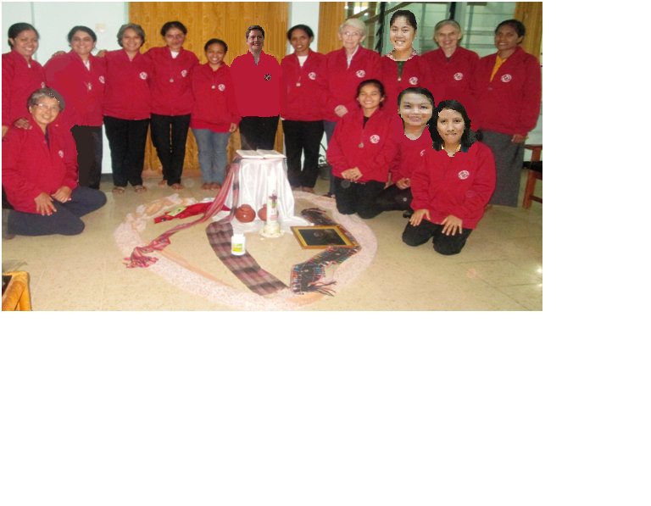

Chizuyo Inoue, Hortencia Ferreira, Gerardette Philips, Jovita Triwiludjeng, Henni Sidabungke, Adriana deAraujo Dosantos, Teresa Ryden, Natalia Dorego, Nance O’Neil, Adriana Gulo, Nancy Murphy, Filomena Soares Amaral,

Lusni Sitanggang, Erica Atiti Jaliana Lahagu, Ermenilda Ahus